**Page Customization: Functional Requirements**

1. The system must allow users to select the setting menu
2. The system must allow users to choose color scheme for the chat
3. The system must allow administrative users to review the modifications
4. The system must allow users to see the new screen

**Page Customization: Non-Functional Requirements**

1. The system shall prompt users to page customization menu
2. The system shall update the selected color scheme in 12 seconds
3. The system shall notify the chat admin to authorize the new change
4. The system shall generate a new chat message screen for the users

**Page Customization: Use Case Diagram**

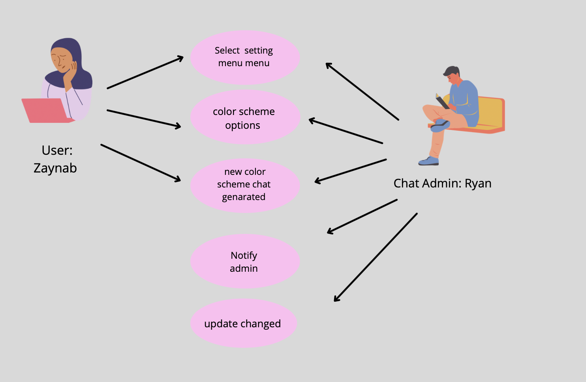

**User Status: Functional Requirements**

1. There should be an option to change the user status
2. Profile pictures should have a small space to show their user status
3. User status set by A should match what other people see on A’s profile
4. If user status is set for some time, the system should show the status as available after that time

**User Status: Non-Functional Requirements**

1. User status set by A should be seen immediately in other’s screen
2. User status set by a user should be accurate to what others see
3. Features to change the user status should be usable when clicking the profile picture

**User Status: Use Case Diagram**

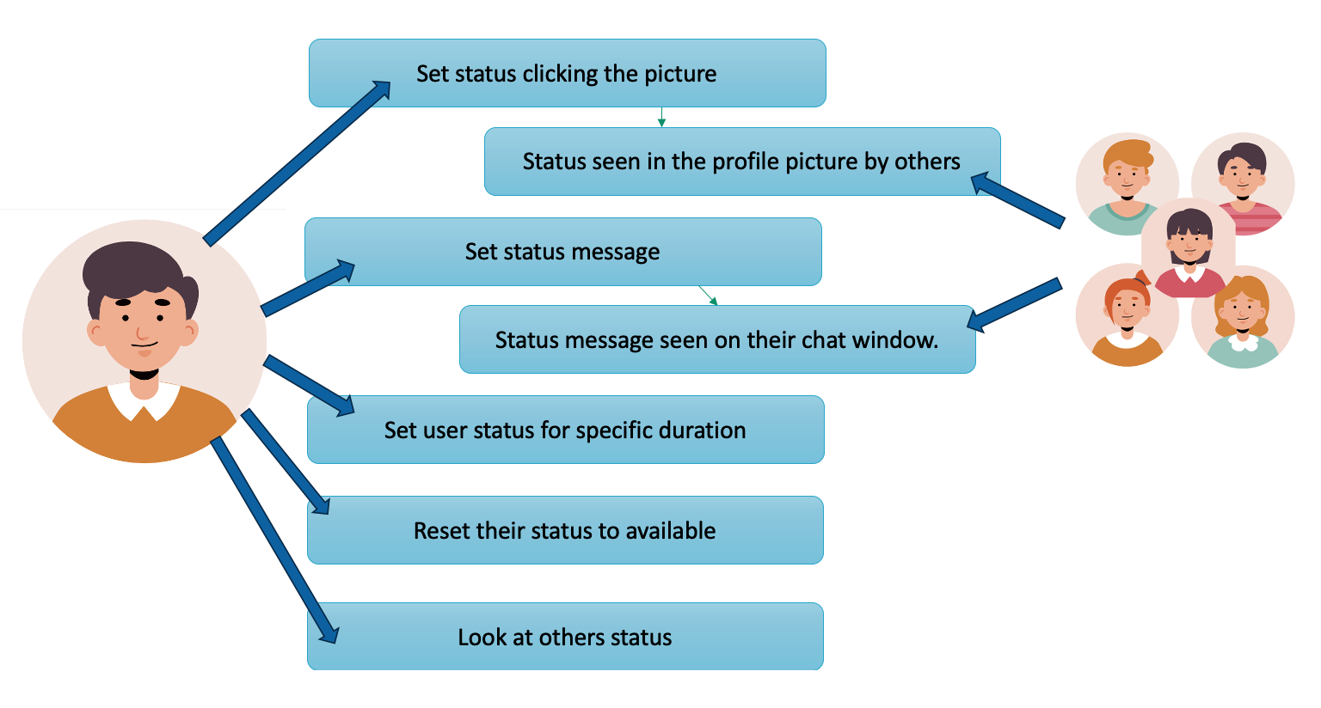

**Activity Center: Functional Requirements**

1. The system must allow users to create their own emotes
2. The system must have a screen (activity center) for users to see emotes to their posts
3. The system must have an option to enable emote notifications

**Activity Center: Non-Functional Requirements**

1. The system shall be easy to navigate
2. The system shall display emotes with enough resolution to tell what they are
3. The system shall load images quickly

**Activity Center: Use Case Diagram**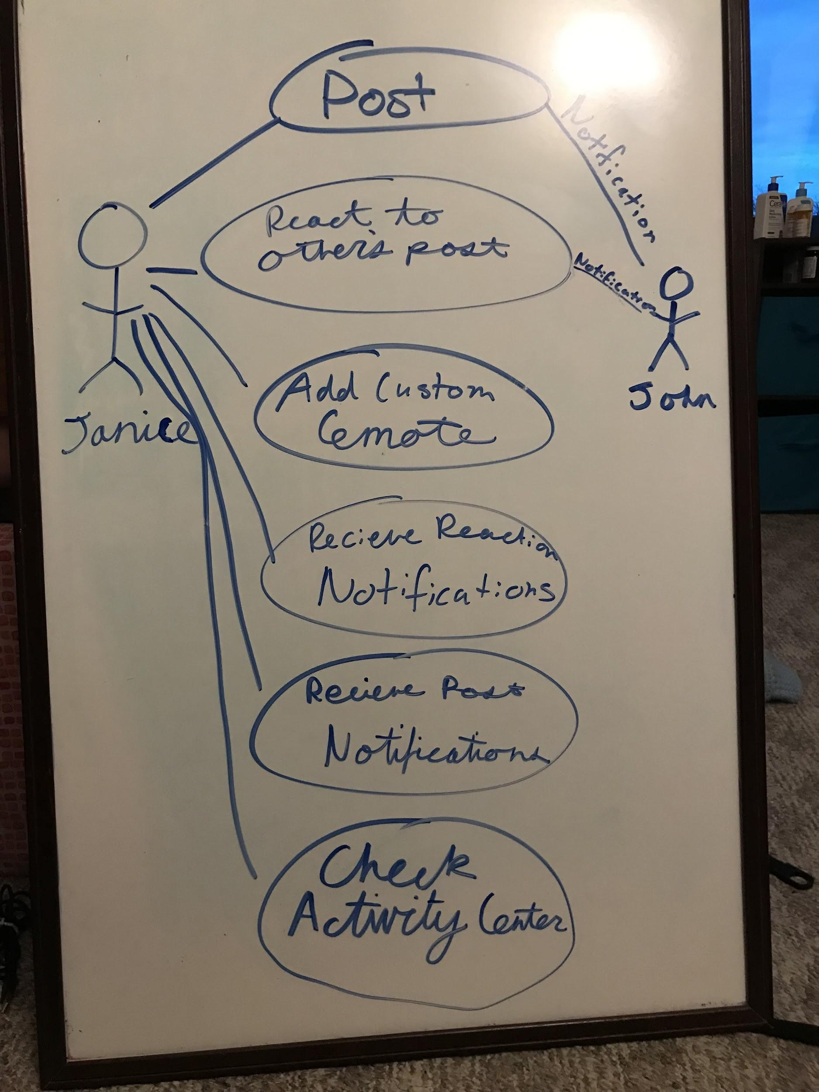

**Location: Functional Requirements**

1. The system allows users to share their location with others.
2. The system shares the current location of the user.
3. The location will be sent by pressing a button next to the name of the user which will receive the location.

**Location: Non-Functional Requirements**

1. The system has to be easy to access.
2. The system has to be easy to understand.
3. The system will have a very detailed image of the location area.

